Contax and Nikon Rangefinder Bayonet Mount Lenses
When I saw the bright Nikon S2 in a used camera store in Osaka Japan in the summer of 2003, I knew it had to be mine. The Nikon is a classic camera of the late 1950s that uses the Nikon 'S' mount, a bayonet mount that is similar to the Contax 'C' rangefinder mount used in classic Contax rangefinders of the 1930s-1960s (not the current Contax G range).
Later, I found a mint condition Nikon S3 with mint 105mm f/2.5 that also had to be mine, and bought it.
The Nikon mount is almost identical to the Contax mount. Lenses from both systems will mount on each other, but because Nikon used Leica's standard of 51.6mm focal length for their standard lens, rather than the 52.3 of Contax's system, there is a very slight incompatibility between the Nikon and Contax system. Infinity is the same on both, but there is a 7° maximum difference in close focusing between the two.
For focusing at infinity or when using wide-angle lenses, this slight difference is enveloped within the depth-of-field of the lens. But when using large aperture normals (50mm f/1.4) or long lenses (>75mm), there will be a focusing disparity at short distances.
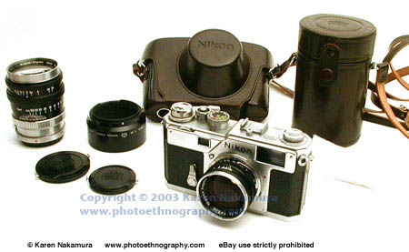
Kiev and Contax: More information about the Kiev series of Contax descendants is on my Kiev 4a page. Suffice it to say here that Former Soviet Union (FSU) lenses that use the Kiev/Contax mount are totally compatible with the Contax system. And you can use FSU Kiev/Contax wide-angle lenses on Nikons without a problem although the long lenses will run into the same Contax/Nikon incompatibility. Here is my Nikon S2 pictured with the excellent Jupiter-12 35mm f/2.8 clone of the Zeiss Biogon (along with its normal 50mm lens inverted).
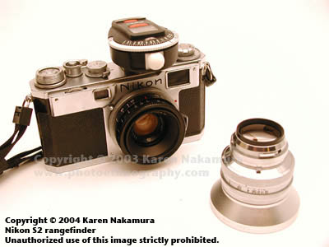
Cosina-Voigtlander: Cosina of Japan has recently announced the first new production lenses for the Nikon 'S' and Contax 'C' mount for over three decades. The new wide angles in particular use aspheric surfaces and look to be excellent. I'm really excited about this! They've also produced Bessa R2S and R2C cameras, which are compatible with the Nikon and Contax rangefinder mounts, respectively.

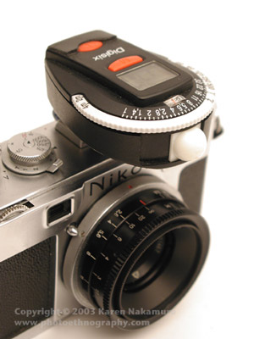
Wide Angle Lenses
Former Soviet Union Lenses:
Jupiter-12 35mm f/2.8: The Jupiter-12 is a copy of the Zeiss Biogon, a very famous 35mm f/2.8 design. Because it isn't retrofocus, the rear element almost touches the focal plane curtains of Nikons/Contaxes. The rear element actually hits the double metal shutters of the Bessa R2S/C and cannot be used with those models. But... with all those caveats... if you have a camera that works with the Jupiter-12, then it's a stellar lens. The non-retrofocus design means that there is very low distortion. Overally, very, very high quality. It's a bit of a pain storing the lens when it's off the camera because the rear element is so vulnerable. Don't buy it unless it comes with the rear lens cap especially designed for it.

Technical Details - Wide Angle Lenses (italics = I wish I had or I sold [and regret])
Manufacturer | Nikon |  | Arsenal | Zeiss
Lens | 35mm f/1.8 W-Nikkor | 35mm f/2.5 W-Nikkor | 35mm f/2.8 Jupiter-12 | 35mm f/2.8 Biogon
Serial# |  |  | 900146x
Place of Manufacture | Japan |  | USSR
Date of Manufacture | 1956-6x | 1952-61 | ? | 1952-61
Lens Construction | 7 elements in 5 groups (modified Gauss?; Xenotar type) | 6 elements in 4 groups (Gauss type) | 6 elements in 4 groups  Resolution: 34/12 | x elements in x groups (Gauss type)
Lens Mount | Nikon RF Bayonet Mount |  | Contax RF Bayonet Mount
Focusing range | 0.9 meter - infinity  63° Angle of View (AoV) | xx meter - infinity  Right focusing (infinity at right)  62° Angle of View (AOV) | 0.9 meter - infinity  Left focusing (infinity at Left)  62° Angle of View (AoV) | xx meter - infinity  Right focusing (infinity at right)  63° Angle of View (AOV)
Apertures | f/1.8, f/2.0 ~ f/22 (x stop steps) | f/2.5, f/2.8 ~ f/22 (x stop steps) | f/2.8 ~ f/22 (1 stop steps) | f/2.5, f/2.8 ~ f/22 (x stop steps)
Filter Mount | Filter: 43mm threaded  Lens cap: 48mm push on  (Nikon Mount) | Filter: 43mm threaded  Hood: 43mm spring | Filter: 40.5mm x 0.5 threaded  Lens cap: xxmm push on | Filter: xxmm threaded  Hood: xxmm spring
Body Construction | Light alloy | Originally chrome plated brass.  Change to light alloy after 1958 | Aluminum | Originally chrome plated brass.  Change to light alloy after 1958
Dimensions and weight | 55.8mm D. x 39.5 mm L  160g  (Nikon mount) | 55.8 mm dia. x 34.8 mm  110 g (post-1958 model) | 60 mm D x 52 mm H  115g
Retail price | ¥39,500 (1958)  ¥33,600 (1959)  ¥27,500 (1961)  ¥27,000 (1962)  (Nikon Mount) | ¥27,500 (1958)  ¥22,000 (1959)  ¥18,000 (1961)
Note: Using the text or images on this site in an ebay auction without permission is a violation of your ebay Terms of Service. I will report you to ebay if I discover such a violation taking place. This may result in your account being cancelled. I also reserve the right to file claim for civil penalties.

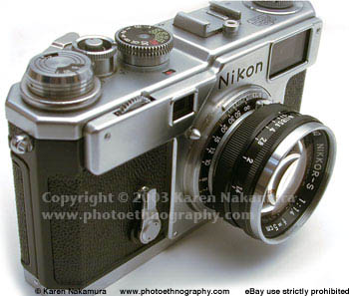
Standard and Long Lenses
The standard Nikkor 5cm (50mm) f/1.4 lens on the Nikon 'S' rangefinders is renowned for its sharpness and clarity. It had a very long production life, basically existing from the first Nikon S to the last Nikon S4. During its production, it went from chromed brass to black painted aluminum, as seen on the Nikon S3 to the right. The optical formula remained the same. It also lost the 'C' in Nikkor-S.C. which indicated coating. Nikon decided that since lenses from all manufacturers were being coated in the post-War period there was no reason to advertise it anymore.

Technical Details - Standard and Long Lenses
Lens | Nikkor-S-C. 5 cm f/1.4 | Nikkor-S 5cm f/1.4
Manufacturer | Nippon Kogaku
Place of Manufacture | Japan
Date of Manufacture | 1953-  Serial #32200~37400 or so (Rottolini) | Serial #37400~417862 or so (Rottolini)
Lens Construction | 7 elements in 3 groups (all single coated)
Lens Mount | Nikon RF mount (bayonet)
Focusing range | 1.0m - infinity (3 feet - infinity)  (left focusing - infinity on left)
Apertures | f/1.4~ f/16 (1 stop steps)
Filter Mount | 43mm screw-in
Dimensions and weight | Chromed brass  145g (5.1oz) | Black painted aluminum  133g (4.7oz)
Retail price | $169.50 in 1953 | ¥
Note: Using the text or images on this site in an ebay auction without permission is a violation of your ebay Terms of Service. I will report you to ebay if I discover such a violation taking place. This may result in your account being cancelled. I also reserve the right to file claim for civil penalties.

Nikkor-P 10.5cm f/2.5  The Nikkor-P 10.5cm (105mm) f/2.5 lens is one of the lenses that won Nikon over in the United States. It was bitingly sharp with excellent resolution. Photojournalists were flocking to the Nikon system. This lens has a long and hallowed life. After its incarnation as a Nikon Rangefinder Lens, it was reborn as a Nikon 'F' mount SLR lens.  I bought my 105mm in mint condition with case and caps as part of a larger lot that included my Nikon S3. It was really quite a coup since these lenses are getting rare, and the caps and hoods for them are getting even rarer. | 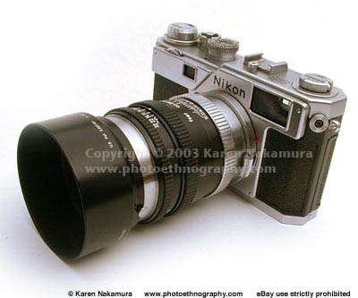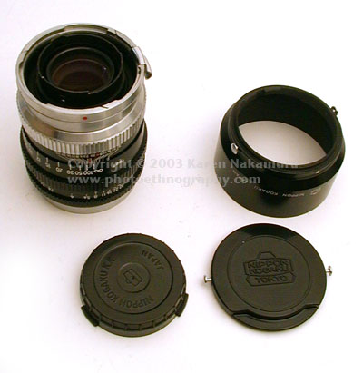

Lens | Nikkor-P 10.5 cm f/2.5 | 135mm f/3.5 Nikkor Q-C
Manufacturer | Nippon Kogaku
Place of Manufacture | Japan
Date of Manufacture | 1953-  22,000 produced  My unit (serial #922xxx) produced in last block | 1950-  1953-  1956-
Lens Construction | 5 elements in 3 groups (all single coated) | 4 elements in 3 groups
Lens Mount | Nikon RF mount (bayonet)
Focusing range | 1.3m - infinity (4 feet - infinity)  (left focusing - infinity on left) | 1.5 meter (5') - infinity  18° Angle of View (AoV)
Apertures | f/2.5, f/2.8 ~ f/32 (1 stop steps) | 1950: f/3.5 ~ f/16  1953: f/3.5 ~ f/32  1956: f/3.5 ~ f/32
Filter Mount | 52mm screw-in (Series VII) | Filter: 43mm threaded
Dimensions and weight | 525g (18.5 oz) | 1950: 510g  1953: 475g  1956: 397g
Retail price | $152.50 | ¥
Note: Using the text or images on this site in an ebay auction without permission is a violation of your ebay Terms of Service. I will report you to ebay if I discover such a violation taking place. This may result in your account being cancelled. I also reserve the right to file claim for civil penalties.

Manufacturer |  | Arsenal | Arsenal
Lens |  | 5cm f/2 "Jupiter 8M"  (although it's labelled 5cm, the actual focal length is 52mm) | 85mm f/2 "Jupiter-9"
Place of Manufacture |  | USSR | USSR
Serial #
Date of Manufacture |  | 1958~
Lens Construction |  | Zeiss Sonnar clone  5 elements in 3 groups | Zeiss Sonnar clone  7 elements in 3 groups
Lens Mount | Kiev/Contax RF Bayonet Mount
Focusing range |  | 0.9 meter - infinity  Left focusing (infinity at left)  45° Angle of View (AOV) | 1.15 meter - infinity  Left focusing (infinity at left)  xx ° Angle of View (AOV)
Apertures |  | f/2.0 ~ f/22 (1 stop click stops)  9 aperture blades | f/2.0 ~ f/22 (xx click stops)  15 aperture blades
Filter Mount |  | Filter: 40.5mm threaded | Filter: 49mm threaded
Body Construction
Dimensions and weight |  | 49mm D x 35 mm H  130g | 60mm D x 65 mm H  335g
Retail price |  | $30-60 on eBay (2003)
Note: Using the text or images on this site in an ebay auction without permission is a violation of your ebay Terms of Service. I will report you to ebay if I discover such a violation taking place. This may result in your account being cancelled. I also reserve the right to file claim for civil penalties.

Lens Collection Martrix
 | Leica M39 | Leica M | Pentax M42 | Nikon RF | Nikon F | Canon FD | Canon EF
15 | 15 f/4.5
17 |  |  | 17 f/4
20 |  |  |  |  | 20 f/2.8
24 |  |  |  |  | 24 f/2.8 | 24 f/2.8 | 24 f/2.8
25 | 25 f/4
28 |  | 28 f/2.8 | 28 f/2.8
35 |  | 35 f/2
35 |  | 35 f/2.8 | 35 f/2.8 | 35 f/2.8
40 |  | 40 f/2
45 | 45 f/2.8
50 | 50 f/1.4 |  | 50 f/1.4 | 50 f/1.4 |  | 50 f/1.4 | 50 f/1.4
50 | 50 f/1.5 |  |  |  |  | 50 f/1.8
50 |  | 50 f/2
50 | 50 f/3.5
52 | 52 f/2
58 |  |  |  |  | 58 f/1.4
85 | 85 f/2
90 |  | 90 f/4
100 |  |  |  |  |  |  | 100 f/2.8
100 | 100 f/4
100 | 100 f/4
105 |  |  |  | 105 f/2.5 | 105 f/2.8
135 | 135 f/3.5 |  | 135 f/3.5 | 135 f/3.5
135 | 135 f/4
 |  |  |  |  |  |  | 28-135 f/3.5 - 5.6

